4 Universal Management Tunnel (UMT) Architecture

4.2 UMT Architecture
A typical PON is deployed with an OLT at the local Central Office (CO) and several ONUs which are connected to the Outside Distribution Network (ODN) comprising at least one fiber spliter. The OLT acts as the management master responsible for controlling individual connected ONUs, including MPCP / OAM registration, service provisioning, etc., as defined in IEEE Std 1904.1-2013.

4.2.1.Single hop between Management Master and OLT
In this scenario, the Management Master is collocated with the OLT within the CO, and it is has access to all information within the OLT, such as status of individual ONUs, QoS profiles assigned to individual services, device status, etc.. Physically, the Management Master in this architecture would have a form of a software agent running on the OLT hardware. This arrangement is shown in Figure 1.

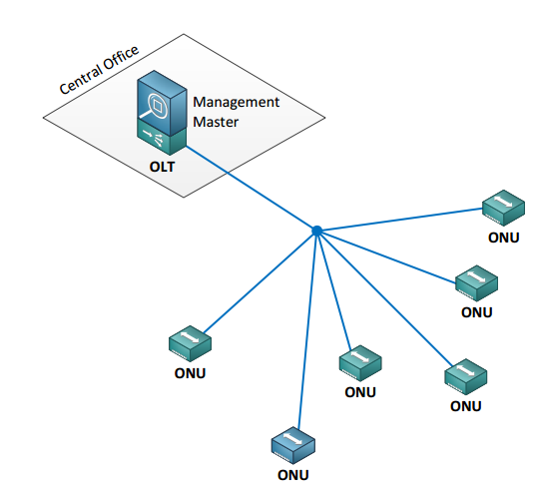
Figure 1 – Single hop between Management Master and OLT

4.2.2 Multiple hops between Management Master and OLT
In that example, the Mangment Master does not have a direct access to the OLT, but it shares the same L2 network, providing access to information stored within the OLT via standardized interfaces. The Management Master and the OLT are separated by a number of layer 2 hops. Physically, the Management Master in this architecture would have the form of a software agent running on either a dedicated or virtual machine, physically separate from the OLT, but otherwise connected to the same LAN. The Management Master in this case can be shared by more that one OLT, provided that all these OLTs are connected to the same LAN. This arrangement is shown in Figure 2.
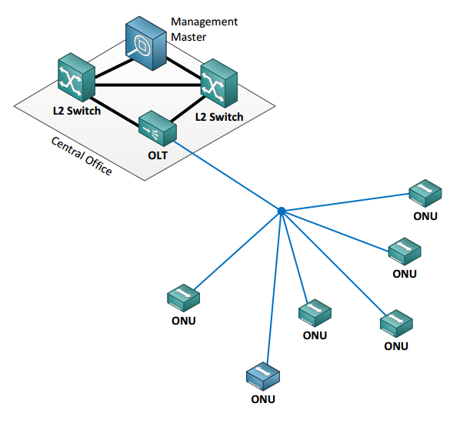
Figure 2 – Multiple hops between Management Master and OLT

4.2.3 Management Master sharing L3 network with EPON OLT
In that example, the Mangment Master is connected (directly on indirectly) to the core transport network of the operator and manages a number of OLTs connected (directly or indirectly) to the same core transport network. The Management Master is provided access to information stored within the OLT via standardized interfaces. Physically, the Management Master in this architecture would have the form of a software agent running on either a dedicated or virtual machine, physically separate from the OLT, but otherwise reachable via IP level connectivity. The Management Master in this case can be shared by more that one OLT, provided that all these OLTs are connected at the IP level. This arrangement is shown in Figure 3.
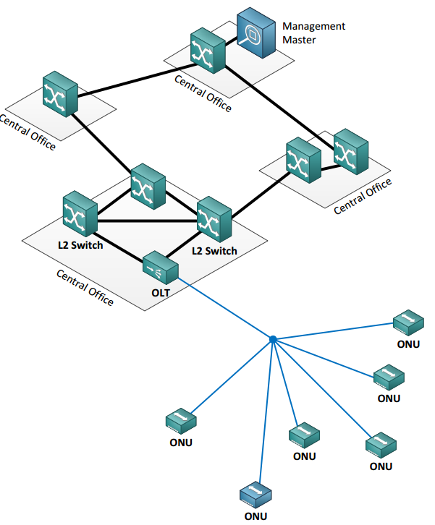
Figure 3 – Management Master sharing L3 network with EPON OLT

